|  |
| --- |
| iActo |
|  |
| iActo User Manual |
|  |

2/2/2018

Revision History

|  |  |
| --- | --- |
| ***Document Owner*** | Ratheesh |
| ***Document Location*** | This document is only valid on the day it was printed and the electronic version is located at /PMO/User Manual |
| ***Document Status*** | ***DRAFT*** |

|  |  |  |  |  |
| --- | --- | --- | --- | --- |
| **Revision #** | **Revision Date** | **Description of Change** | **Author** | **Comments** |
|  |  |  |  |  |
|  |  |  |  |  |
|  |  |  |  |  |
|  |  |  |  |  |

Document Approval

The following User Manual has been accepted and approved by the following:

|  |  |  |  |
| --- | --- | --- | --- |
| **Signature** | **Printed Name** | **Title** | **Date** |
|  |  |  |  |
|  |  |  |  |
|  |  |  |  |
|  |  |  |  |

Distribution

This document has been distributed as follows:

|  |  |  |  |
| --- | --- | --- | --- |
| **Name** | **Responsibility** | **Date of issue** | **Version** |
|  |  |  |  |
|  |  |  |  |
|  |  |  |  |
|  |  |  |  |

Table of Contents

Preface 1

Manual Purpose 1

Intended Audience / User 1

1 Introduction 1

1.1 Description 1

2 Pre-Setup 1

2.1 Device 1

2.1.1 Specification 1

2.1.2 Installation 2

2.1.3 Uninstalling 5

2.2 Scanner 8

2.2.1 Specification 8

2.2.2 Installation 8

2.3 Printer 9

2.3.1 Specification 9

2.3.2 Installation 9

2.4 Web Application 15

2.4.1 Specification 15

2.4.2 Installation 15

2.5 Route File 16

3 Admin Module 16

3.1 Login 16

3.2 Users 16

3.2.1 Manage Users 17

3.3 Change Password 19

3.4 Logout 20

4 User 20

4.1 Manager 20

4.1.1 Login 20

4.1.2 Manager Dashboard 21

4.2 Picker 24

4.2.1 Login 24

4.2.2 Profile Screen 25

4.2.3 Product Scanning 26

5 Troubleshoot 31

User Guide: iActo

# Preface

# Manual Purpose

iActo is an application designed to simplify the process of “picking and packing” at order fulfilment centres. This operator’s manual provides an in-depth coverage of how to use the system to create an efficient and cost effective “pick pack solution” with a short turn around time

# Intended Audience / User

This manual is geared for various levels of personnel who are employed in a warehouse for the management of stock in the warehouse.

# Introduction

This section gives a scope description and overview of all the contents included in this user manual. The purpose of this document is to give a detailed guidance of the **‘iActo’** application.

## Description

iActo is a system, which is used to manage the stock in the warehouse. It facilitates the systematic retrieval of stock in the warehouse. It mainly consists of five parts,

1. iActo web application
2. iActo mobile application
3. Android mobile device
4. Bluetooth Ring Scanner
5. Printer (No details of the print service is covered…. Moving parts???)
6. What about admin app installation? Confirm if this is out of scope.

The various user roles present in the iActo system are as follows

1. System Admin – Manage users and roles with in the application
2. Floor Manager – Manages picker assignments
3. Picker – Picks orders from the warehouse based on the assignments

# Pre-Setup

## Device

### Specification

* The mobile app requires an Android OS that is Android “Kitkat” and above.
* Mobile device should have a screen size greater than 5.2 inches.
* The Bluetooth version should be 4.1 and above.
* The device should support LTE / Wi-Fi 802.11 a/b/g/n/ac.
* The device should have 3 GB RAM and above memory.

As par the above specification, Verbat prefer ‘Alcatel IDOL 6060S’ device to other devices.

### Installation

The Admin user shall send a mobile application installation link to the picker’s e-mail id. On touching the application link, the picker/user will be redirected to the mobile app ‘Installation’ page.

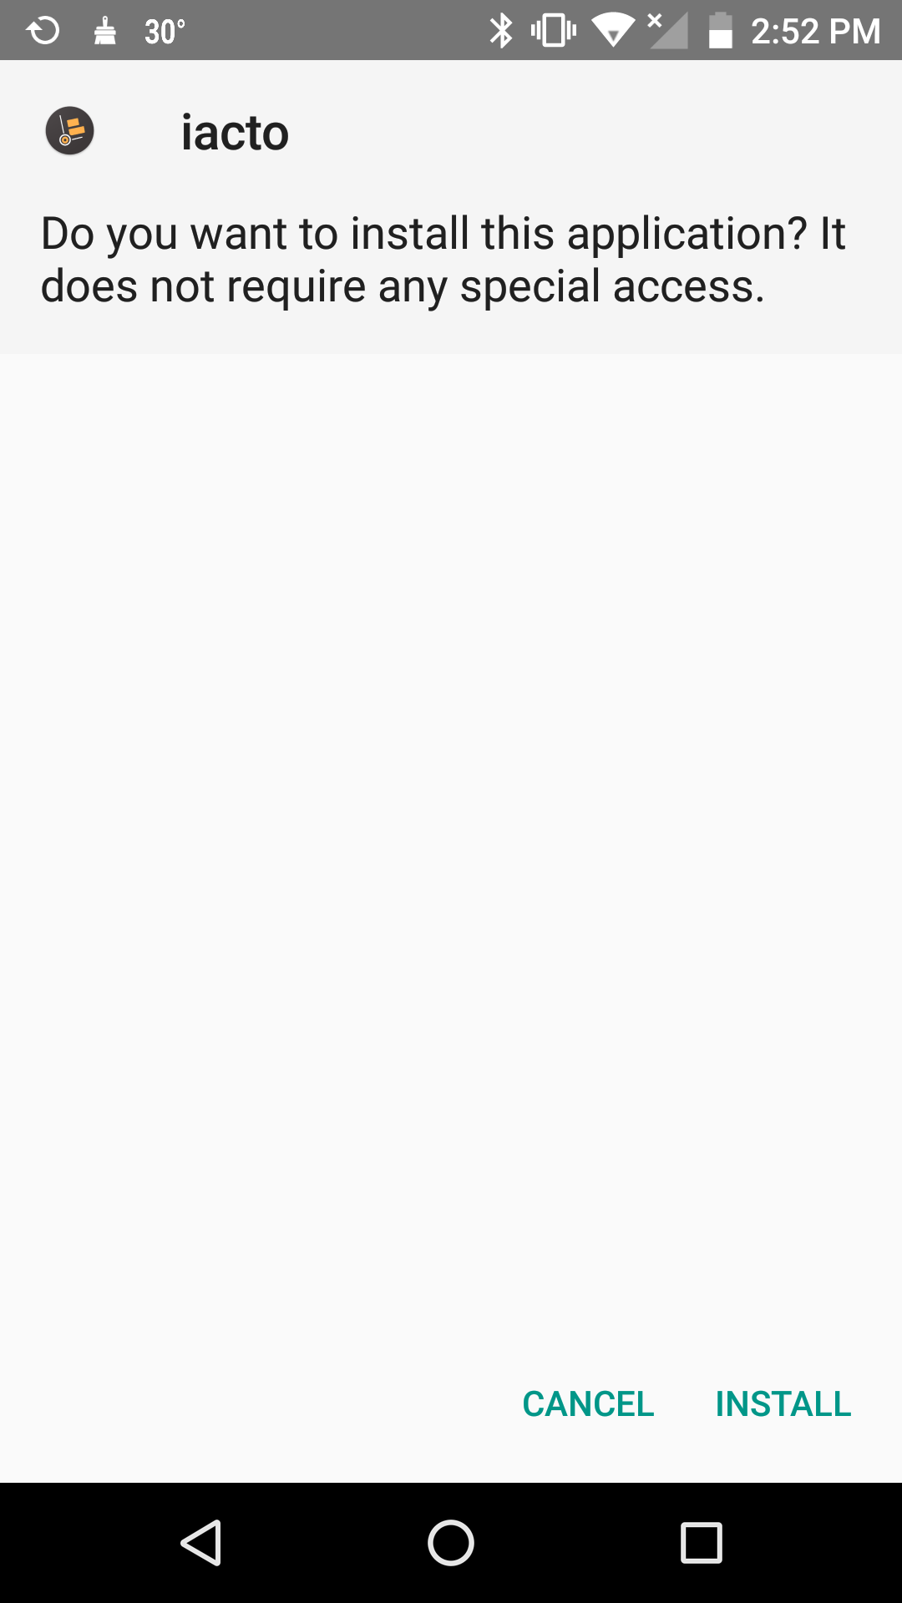

Figure: Mobile App installation Screen 1.1

The installation page provides option to either install the application or cancel the application installation. If the user is ready to install the application, he/she has to tap the ‘INSTALL’ button. The user would then be directed to the installing screen.

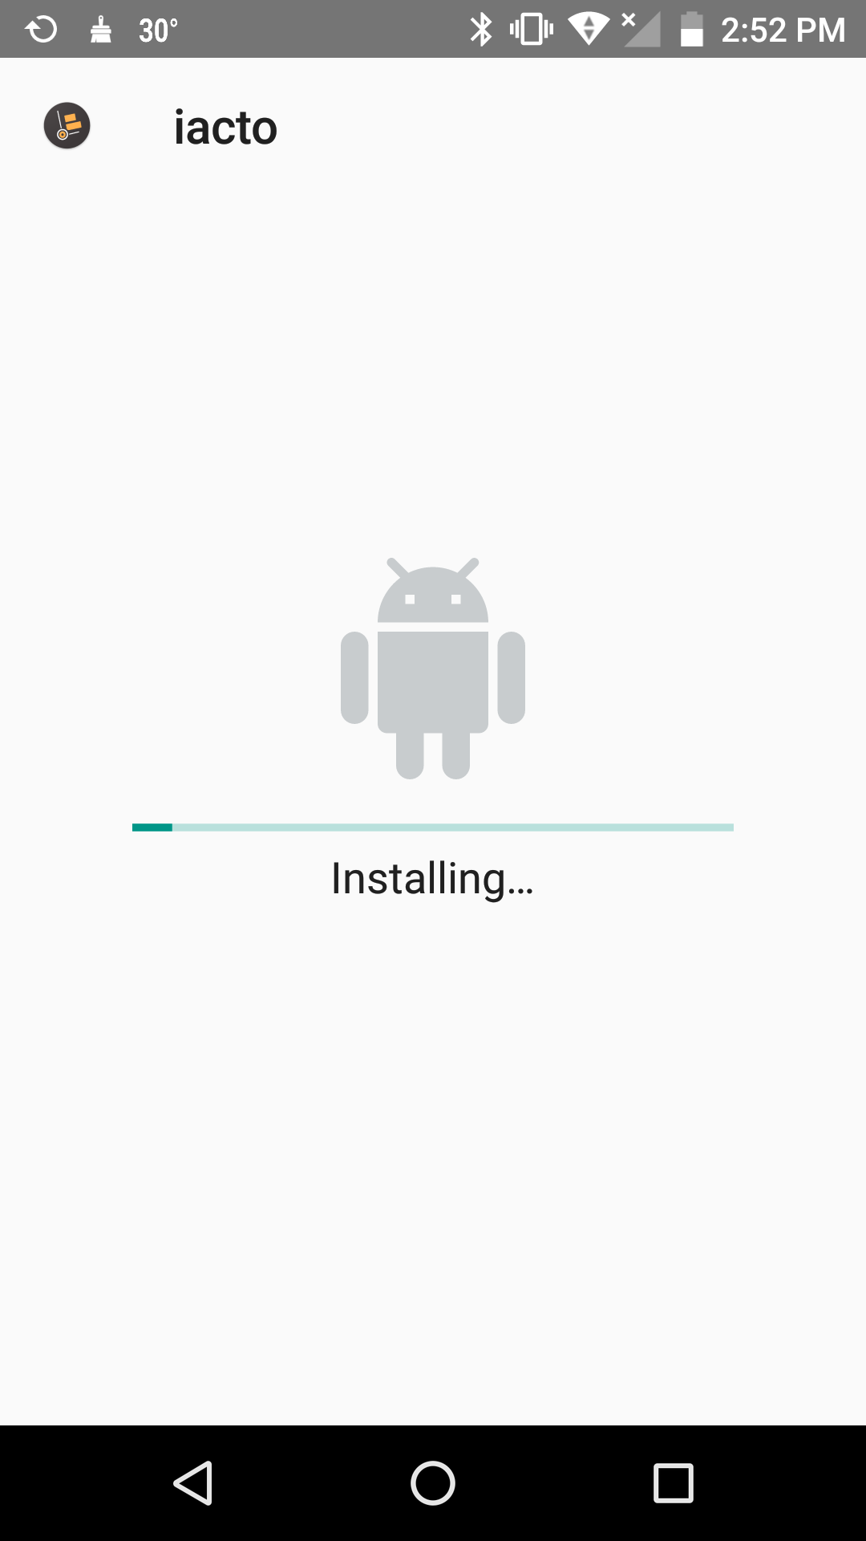

Figure: Mobile App installation Screen 1.2

After successful installation, a message denoting ‘App Installed’ will then be displayed on screen with two options, done and Open.

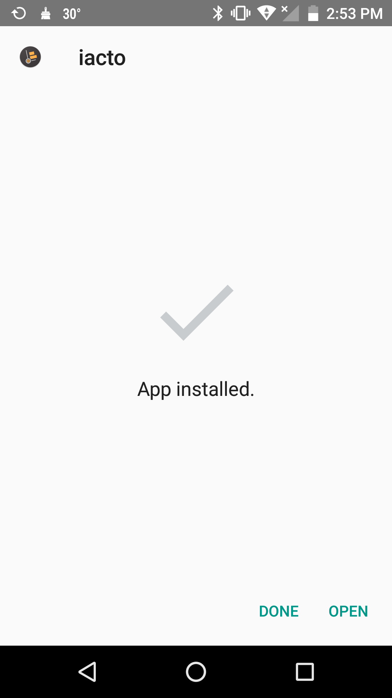

Figure: Mobile App installation Screen 1.3

If the user taps on the ‘DONE’ button, the app icon will be displayed on the app gallery. If the user taps on the ‘OPEN’ button, the app will be opened.

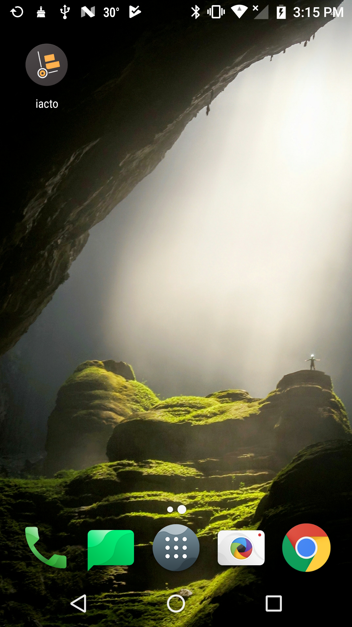

Figure: Mobile App Screen

### Uninstalling

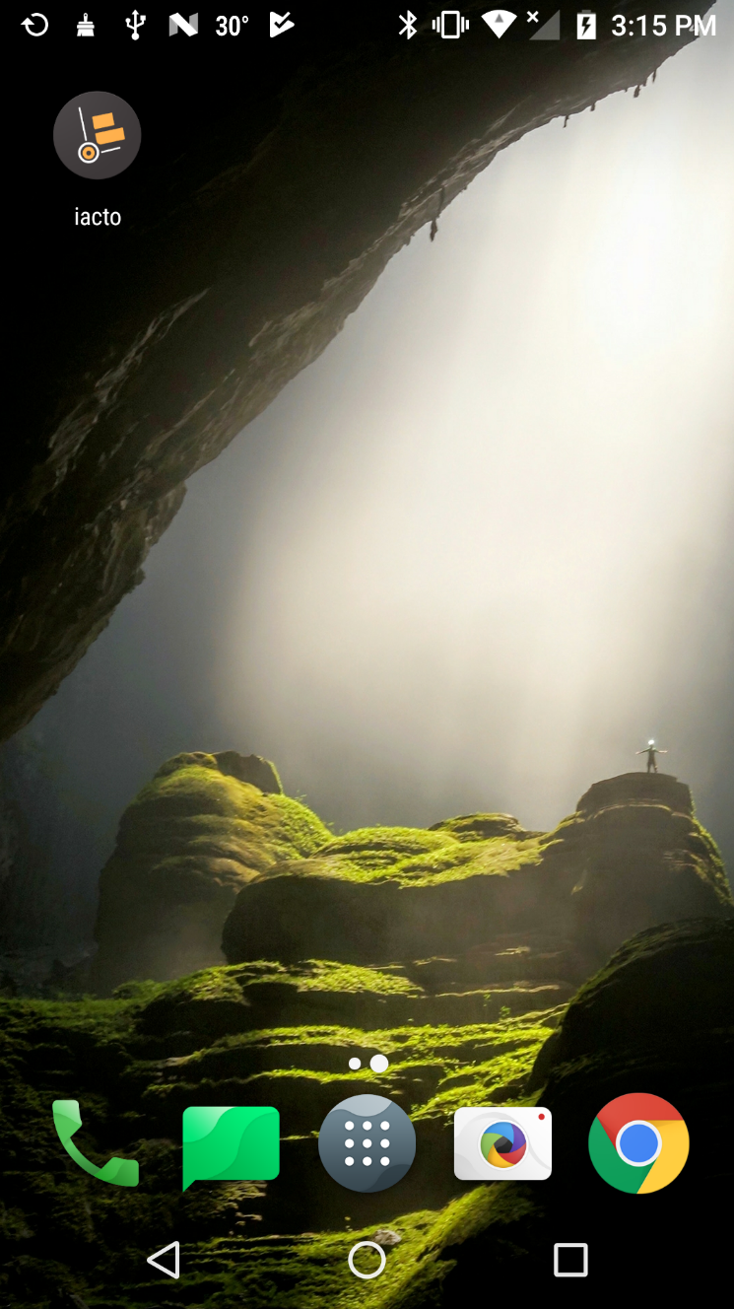

Figure: Mobile App uninstallation Screen 1.1

In order to uninstall the application, go to the main screen, press the application icon for 3-5 seconds and then two options, Remove and Uninstall appear on the screen.

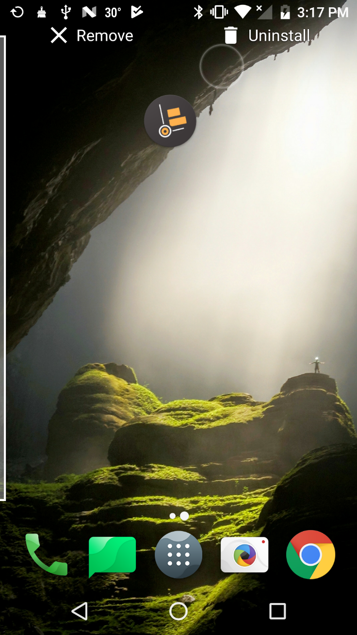

Figure: Mobile App uninstallation Screen 1.2

The application icon is then to be dragged to the uninstall option.

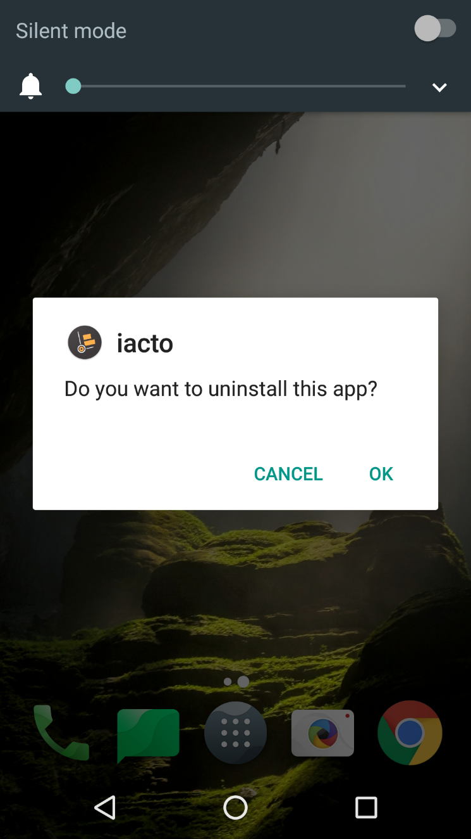

Figure: Mobile App uninstallation Screen 1.3

Following, a pop up message will appear whether to uninstall the application or to cancel uninstallation. On touching ’OK’, the application is uninstalled successfully.

## Scanner

### Specification

Verbat suggest to rather use ‘Symcode’ Bluetooth ring scanner than other Bluetooth scanners.

### Installation

**Pairing Bluetooth Devices**

Initially turn ON the Bluetooth scanner device and enable Bluetooth on your mobile device. Then use Bluetooth device to read the ‘Links pairing mode’ barcode from the user manual of the Bluetooth scanner. Once the ‘Links pairing mode’ barcode is read successfully, Bluetooth device name will get listed under ‘Available devices’ section. Then tap the respective Bluetooth device and the pairing starts.

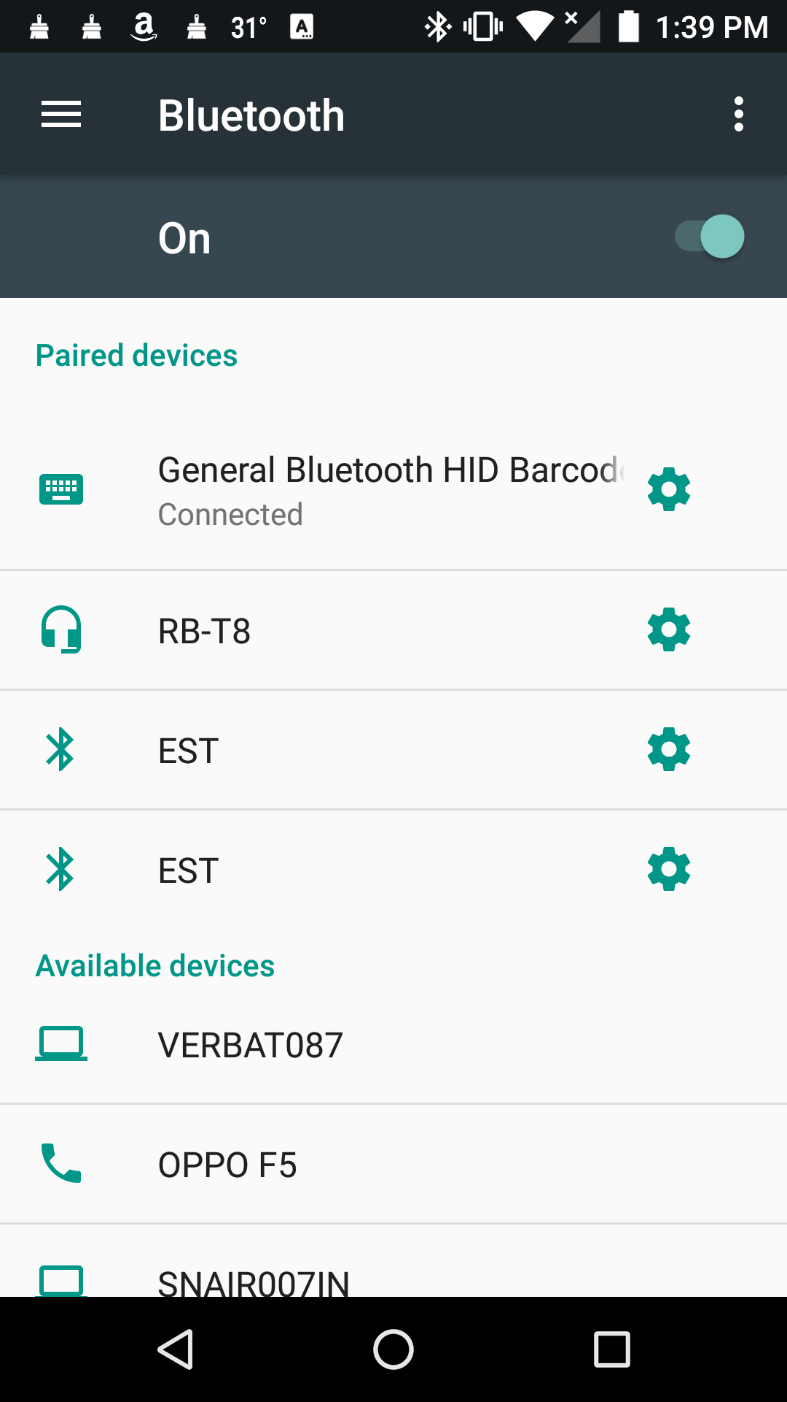

Figure: Bluetooth Pairing Screen

On successful pairing of devices, the Bluetooth indicator lit blue lights in the scanner.

## Printer

### Specification

Verbat suggest to use printers configured with A6 paper size.

### Printer Service Installation

Verbat has created the print service for iActo. In order to avail this service, initially print service setup file link is sent to Admin e-mail id. Click the download link sent via email, select save, and save the zip file. Extract the file from the zipped folder and then click on the setup file.

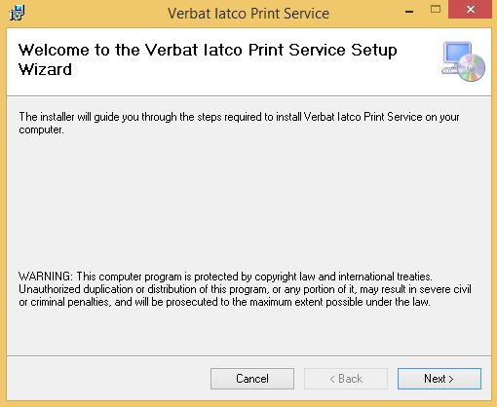

Figure: Print Service Installation Screen 1.1

The ‘Verbat Iacto Print Service Setup’ dialog will open. The dialog box provides option to either install the service or cancel the service installation. If the user is ready to install the service, he/she has to click the ‘Next’ button. The user would then be able to view the ‘Select Installation Folder’ dialog box.

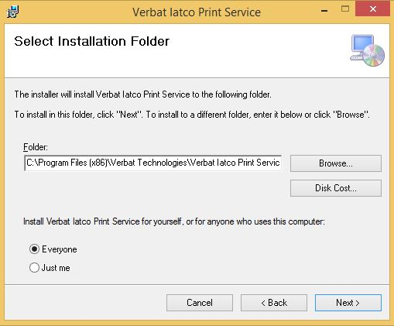

Figure: Print Service Installation Screen 1.2

The ‘Select Installation Folder’ dialog box provides option to either install the service in a default location or browse new location for the service installation. If the user is ready to install the service in the default location, he/she has to tap the ‘Next’ button. Then ‘Confirm Installation’ dialog box is displayed.

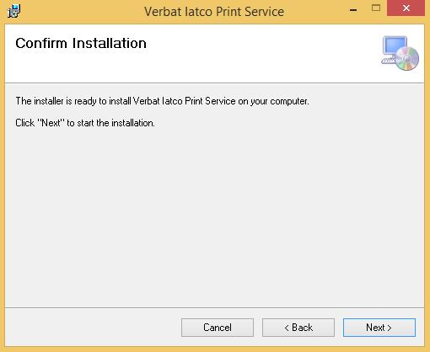

Figure: Print Service Installation Screen 1.3

In order to confirm the installation of this service, he/she has to tap the ‘Next’ button. Following the installing dialog box is displayed on the screen.

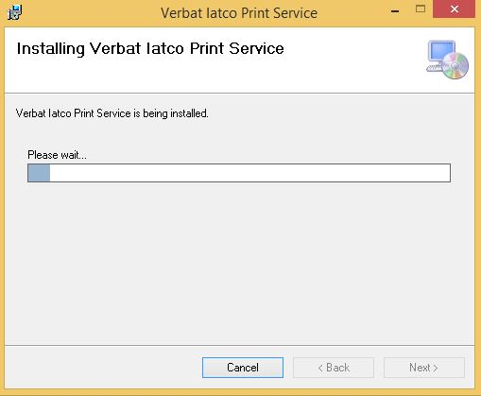

Figure: Print Service Installation Screen 1.4

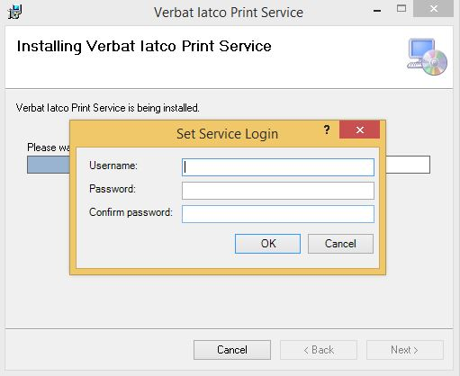

Figure: Print Service Installation Screen 1.5

During the installation, a ‘Set Service Login’ popup dialog box will be displayed. The dialog box provides an option to enter the windows user credentials.

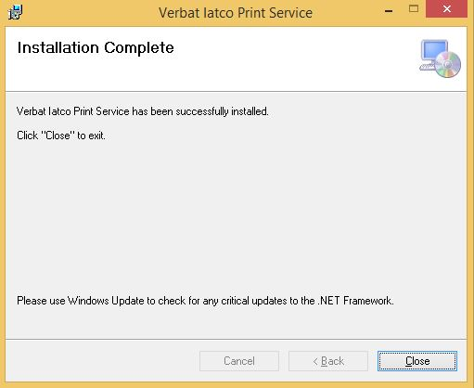

Figure: Print Service Installation Screen 1.6

Finally, if the entered windows user credentials are valid, then an ‘Installation Complete’ dialog box will be displayed.

**Start iActo Print Service**

After successful service installation, press Window key + F to open Run dialog.

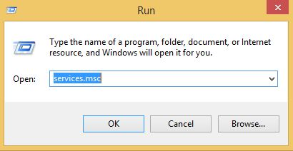

Figure: Print Service Start Screen 1.1

Then enter ‘services.msc’ and click OK button to enter Services.

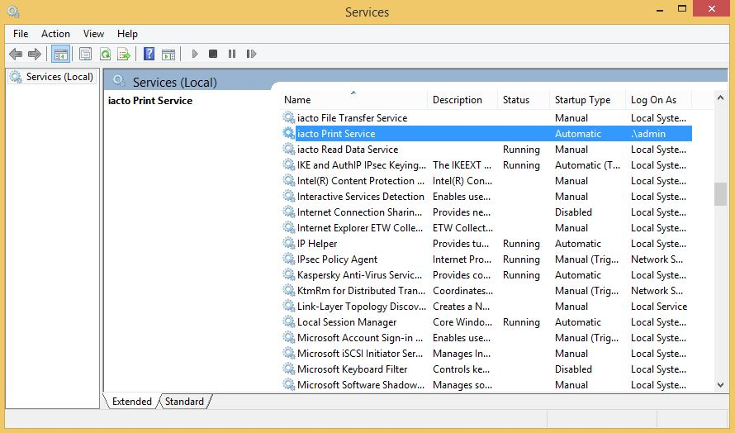

Figure: Print Service Start Screen 1.2

Right click ‘iActo Print Service’ from the Services window, and select ‘Start’ in the context menu.

## iActo Admin Web Application

### Specification

We recommend the specification mentioned below for the best output.

* Computer with Microsoft Windows XP Professional SP3/Vista SP1/Windows 7 or 8 OS
* Processor: 2.6 GHZ Intel Pentium IV or equivalent
* Memory: 4GB
* Disk Space: 1 GB of free disk space

**Browser Compatibility**

The application developed shall be compatible with the browsers listed below:

1. Internet Explorer 11
2. Mozilla Firefox 50 or above
3. Chrome 50 or above

### Installation

Login to the iActo Admin module using URL and Login Credentials given bellow.

URL

<http://demo.iactowms.com/demo/webapp/>

Admin

* User Name : Admin
* Password : 123456

Login to the iActo Manager module using URL and Login Credentials given bellow.

URL

<http://demo.iactowms.com/demo/webapp/>

Floor Manager (is the floor manager the sys admin?)

* User Name : manager
* Password : 123456

## Route File

Admin put all route files in to a Route File folder( What and were is the route file folder?). Every five minutes system automatically uploads all route f**iles present in the route file folder.**

# Admin Module

Admin module is used to manage the application. Verbat creates the admin user. There would be only one admin. The admin account cannot be deleted.

Admin manages the application:

* Manage the users in the application.
* Manage admin (& User????) password

## Login

Admin user can log into the application by entering valid credentials (Username and Password). After inputting the credentials, the user has to click on the ‘Sign In’ button. On validation of the user login credentials, the user will be redirected to the Users page.

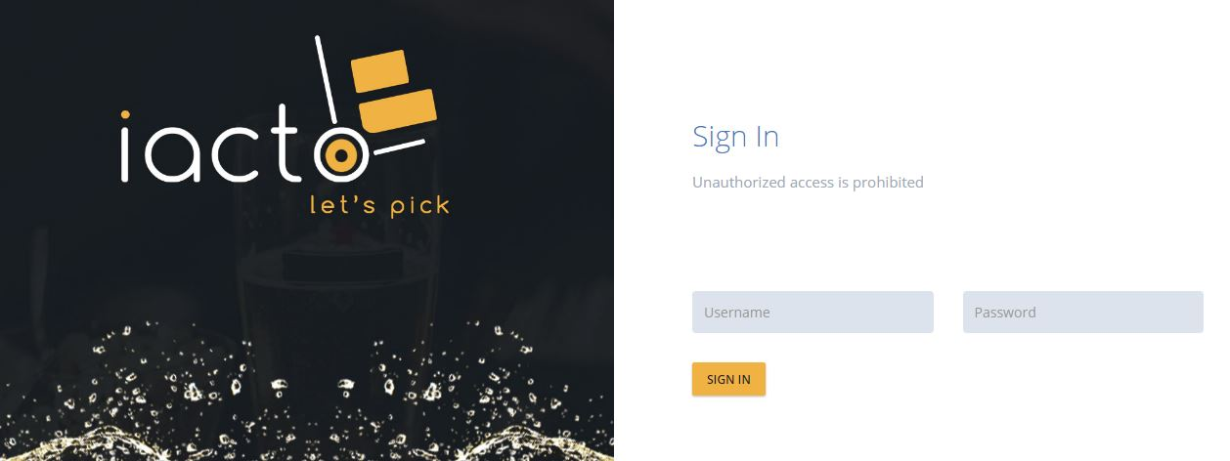

Figure: Admin Login Screen

The username and password are mandatory. If username or password does not match, then an error message, ‘Invalid username or Password’ will be displayed.

## Users

‘Users’ is the default page in the Admin module of the application. On the Users page, admin can view the admin menu. Admin has the option to view and manage the users in the application.

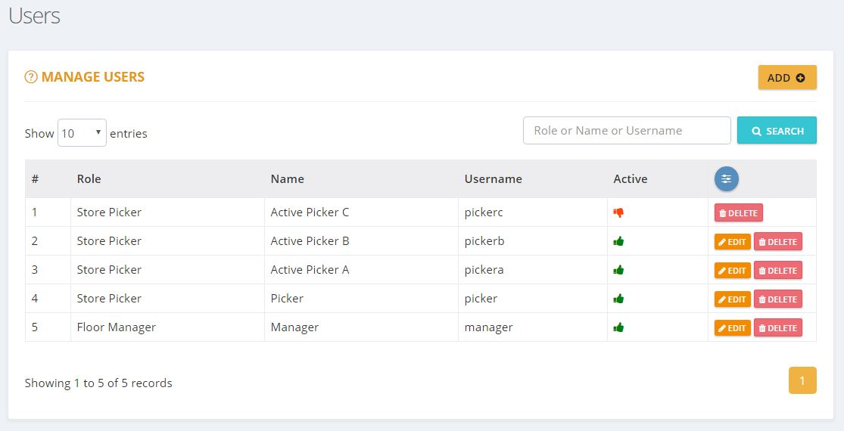

Figure: Users Screen

**Admin Menu:**

Admin can access the menu on the top right corner of the page (is the screen above the correct image?). The menu include the options:

* Users
* Change Password
* Log Out

### Manage Users

Manage Users page will list all the users in the application. The admin can also add/edit/delete user details. Admin user can search for users in this screen.



Figure: Manage Users Screen

The columns listed in the grid are:

* # – Serial number of the list.
* Role – Role type of the user
* Name – Name of the user
* Username – Username
* Active – The ‘thumbs up’ imagedenotes active users whereas the ‘thumbs down’ image denotes inactive users. Inactive users will not be shown anywhere in the application other than ‘Manage Users’ screen.
* Actions – It has two options - Edit and Delete.



* + Edit iconagainst each user can be used to edit the user details.
  + Delete icon  against each user can be used to delete the user details.

There will be a ‘paging’ option, if there are more than 10 rows in the grid.

#### Add User

The Manage Users screen allows the admin to add users. Admin can add a user by clicking ‘ADD’ button on the right side. The admin will then be redirected to ‘Add User’ page.

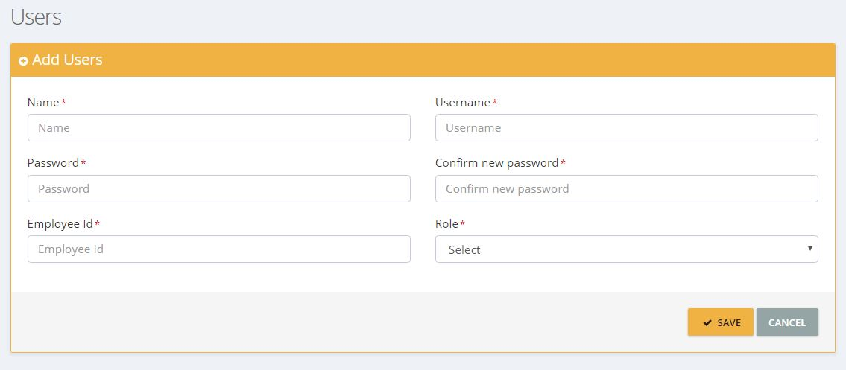

Figure: Add User Screen

Admin can enter the following user details:

* Name
* Username
* Password
* Confirm Password
* Employee ID

After entering all mandatory fields, admin can save the details by clicking ‘SAVE’ button. A message denoting ‘user added successfully’ will then be displayed on screen.

#### Edit User

The admin can edit the user details by clicking the edit icon. The admin will then be redirected to ‘Edit Users’ page.

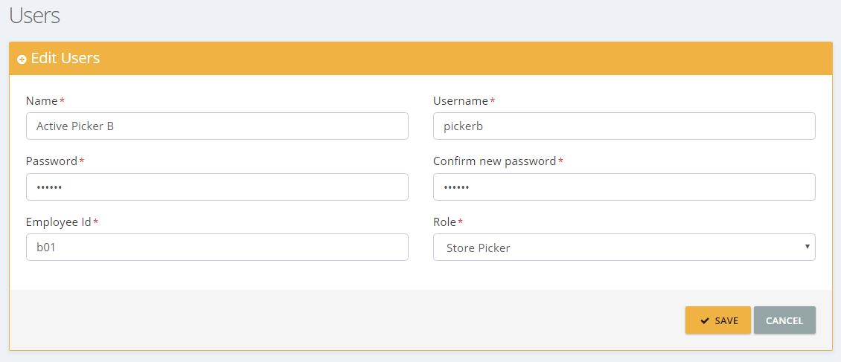

Figure: User Edit Screen

Here the admin can edit and update the user details. The admin can save edited details by clicking ‘SAVE’ button.

#### Delete User

The admin can delete a user by clicking the delete icon. A popup will then be shown to confirm. Upon confirmation, the user details will be deleted from the system.

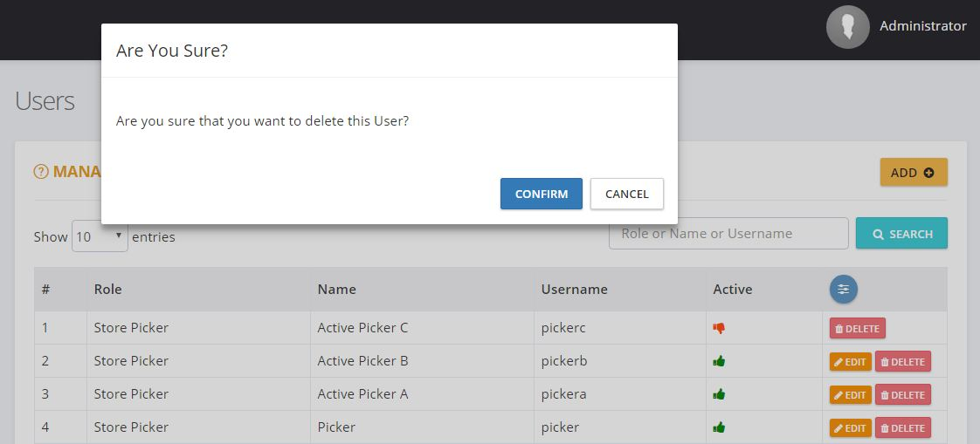

Figure: Delete User Screen

## Change Password

Admin has the option to change current admin password in the application by using ‘Change Password’ option. On clicking the ‘Change Password’ option, the admin will be redirected to ‘Change Password’ page with the following fields:

* Current password
* New password
* Confirm password

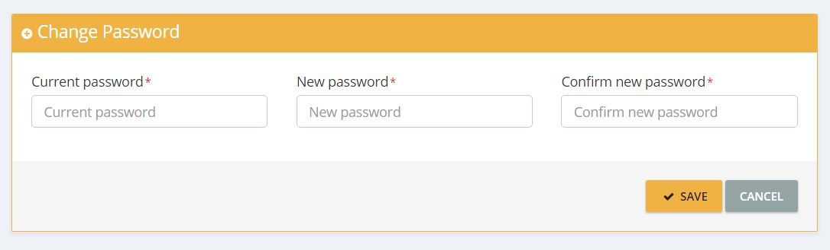

Figure: Change Password Screen

Admin can click ‘SAVE’ button after entering the above details. ‘New password’ and ‘Confirm password’ should be same and valid. The system will verify both new and old passwords, and will update the new password. If verification fails, an error message ‘Invalid Current Password’ will be displayed. On clicking the ‘Cancel’ button, the system will redirect the admin to ‘Manage Users’ page.

## Logout

Admin can exit the application by clicking the ‘Logout’ option. The log-out link will redirect the admin to the ‘Login’ screen.

# User

## Floor Manager

Manager module is used to manage the picker assignment. The manager user is created by the admin.

Manager can manage contents of the application with the following features:

* Manage picker assignment.
* Reset picker password.

### Login

Manager user can log into the application by entering valid credentials (Username and Password). After inputting the credentials, the user has to click on the ‘Sign In’ button. On validation of the user login credentials, the user will be redirected to the Manager Dashboard page.

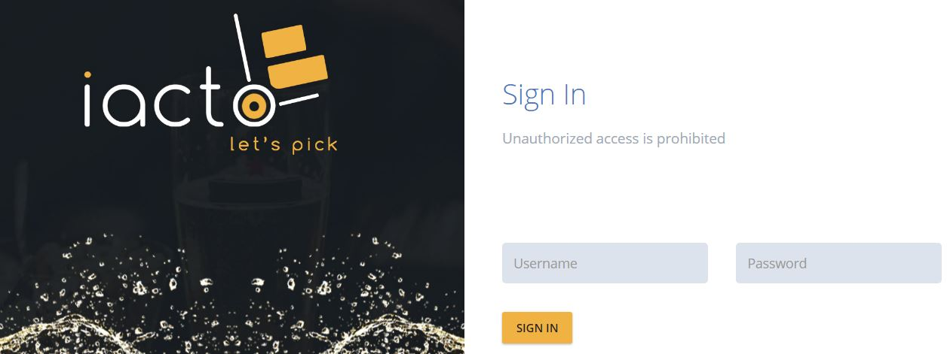

Figure: Manager Login Screen

The username and password are mandatory. If username or password does not match, then an error message, ‘Invalid username or Password’ will be displayed.

### Manager Dashboard

On the Manager dashboard, managers can view the number of routes received, number of routes completed, number of assignments received, number of assignments completed, number of pending cases to pick, assignment status graph, top orders graph, route status graph and ‘Today’s Top 2 Pickers’ graph. Managers get the options ‘assign to picker’ and ‘reset picker password’.

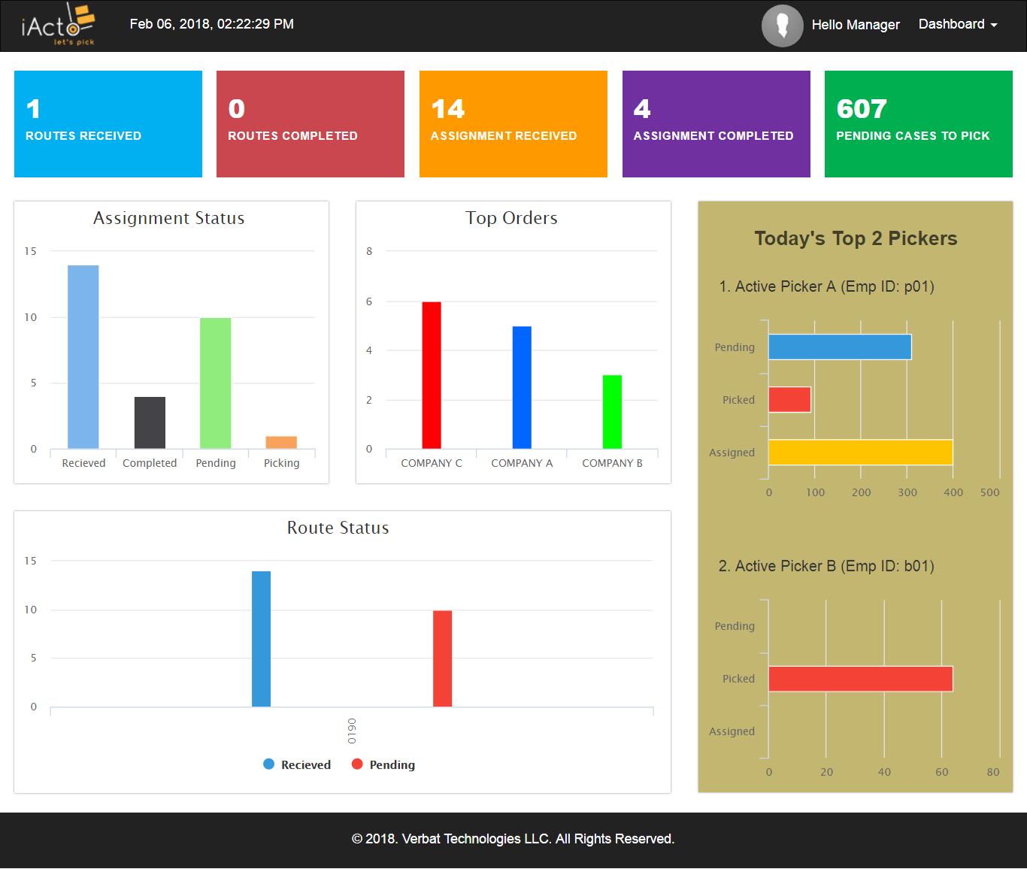

Figure: Manager dashboard Screen

Manager can view the current assignment status of a particular day with the help of ‘Assignment Status’ graph. ‘Top Orders’ graph represent the top five companies that have placed orders based on quantity. A maximum of 35 current routes status details are represented in the route status graph. Current date’s top two pickers are displayed in ‘Today’s Top 2 Pickers’ graph.

**Manager Menus:**

Manager can access the menu by clicking ‘Dashboard’ tab on the top right corner. The menu includes:

* Assign to Picker
* Reset Picker Password
* Change Password
* Logout

#### Assign to picker

By clicking the ‘Assign to Picker’ option from the ‘Dashboard’ tab menu, the user will be redirected to ‘Assign to Picker’ page. Manager can view all active assignments (Previous date/current date) listed in ‘ASSIGN TO PICKER’ table.

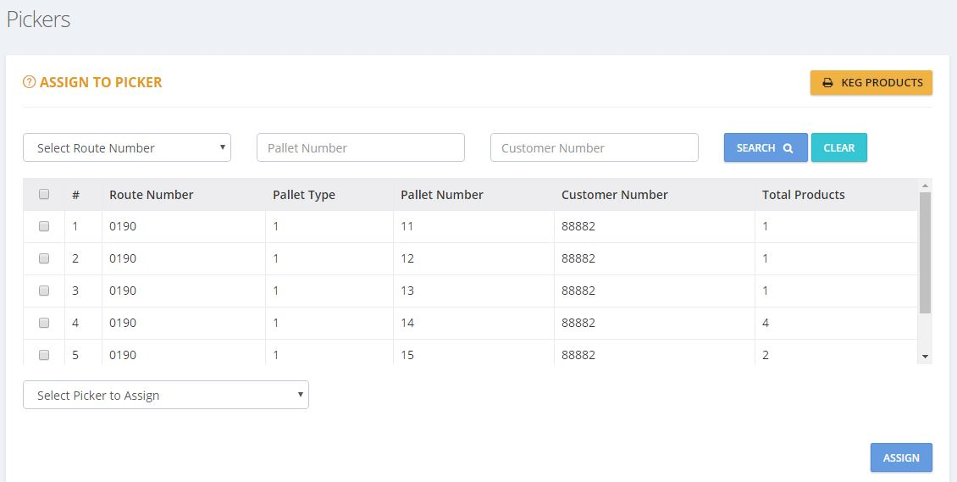

Figure: Assign to Picker Screen

Manager can view ‘Assign to Picker’ page with the following fields:

* Select Route Number
* Pallet Number
* Customer Number
* Select Picker to Assign

The columns listed in the grid are:

* Checkbox
* #
* Route Number
* Pallet Type
* Pallet Number
* Customer Number
* Total Products

Manager can select assignments (all/selected) from ‘ASSIGN TO PICKER’ table, and assign them to a particular picker listed in the ‘Select Picker to Assign’ dropdown field. On clicking the ‘ASSIGN’ button, the selected assignment shall be assigned to the particular picker and a ‘successful assignment’ message will be displayed on the screen. If not, an ‘assignment failure’ message will be displayed. The assignment assigned to a particular picker will not be listed in the ‘Assign to Picker’ table, and cannot be viewed by other pickers. Manager can also search assignments with the help of Select Route Number/Pallet Number/Customer Number fields.

#### Reset Picker Password

The manager can use this option to reset the current picker password.

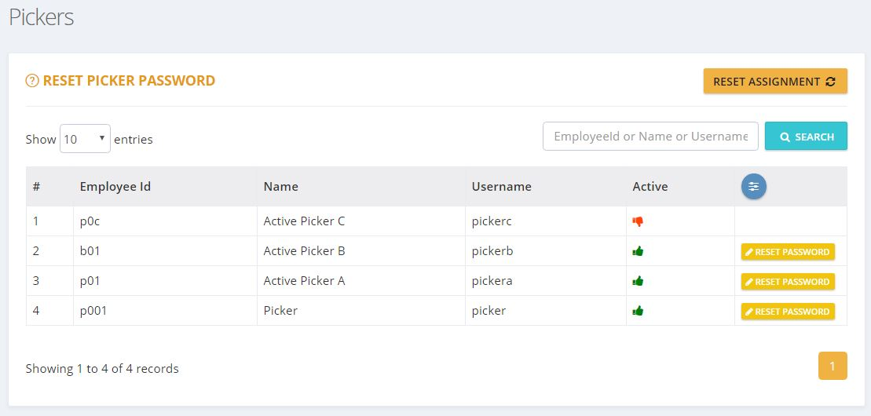

Figure: Reset Picker Password Screen

By clicking the Reset Picker Password option from the ‘Dashboard’ tab menu, the user will be redirected to ‘Reset Picker Password’ page. Managers can view all active and inactive pickers which will be listed in RESET PICKER PASSWORD table. On clicking the ‘RESET PASSWORD’ button of the particular active user from the RESET PICKER PASSWORD table, the user will then be redirected to ‘Reset password here’ page with the following fields:

* New password
* Confirm new password

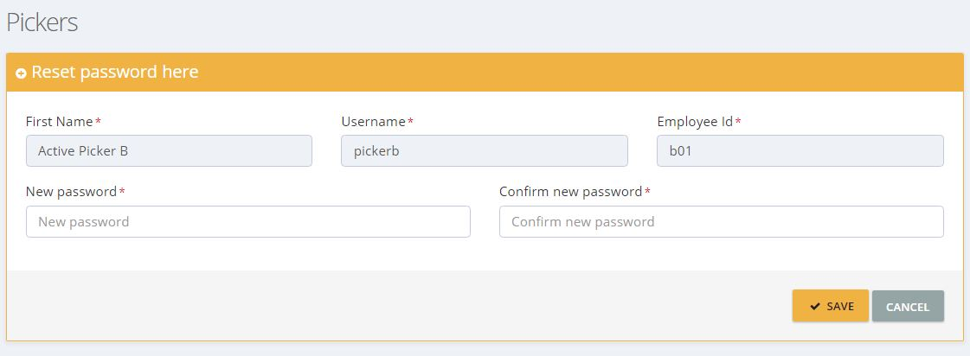

Figure: Reset Password here Screen

Manager can click ‘SAVE’ button after entering the above details. ‘New password’ and ‘Confirm new password’ should be same and valid. The system will verify both ‘new’ and ‘confirm new’ passwords, and will update the new password.

#### Change Password

Manager has the option to change current manager password in the application by using ‘Change Password’ option. On clicking the ‘Change Password’ option, the user will be redirected to ‘Change Password’ page with the following fields:

* Current password
* New password
* Confirm new password

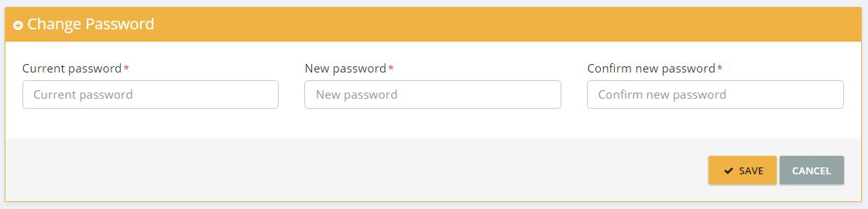

Figure: Change Password Screen

Manager can click ‘SAVE’ button after entering the above details. ‘New password’ and ‘Confirm new password’ should be same and valid. The system will verify both new and old passwords, and will update the new password. If verification fails, an error message ‘Invalid Current Password’ will be displayed.

#### Logout

Manager can exit the application by clicking the ‘Log Out’ option from the menu. The log-out link will redirect the user to Login screen.

## Picker

Picker user can pick orders from the warehouse based on the assignments he received on the mobile app.

### Login

Picker can login to the mobile application by entering valid credentials (Username and Password). After inputting the credentials, the user has to tap the ‘Sign In’ button. On validation of the user login credentials, the user will be redirected to the ‘Profile’ page.

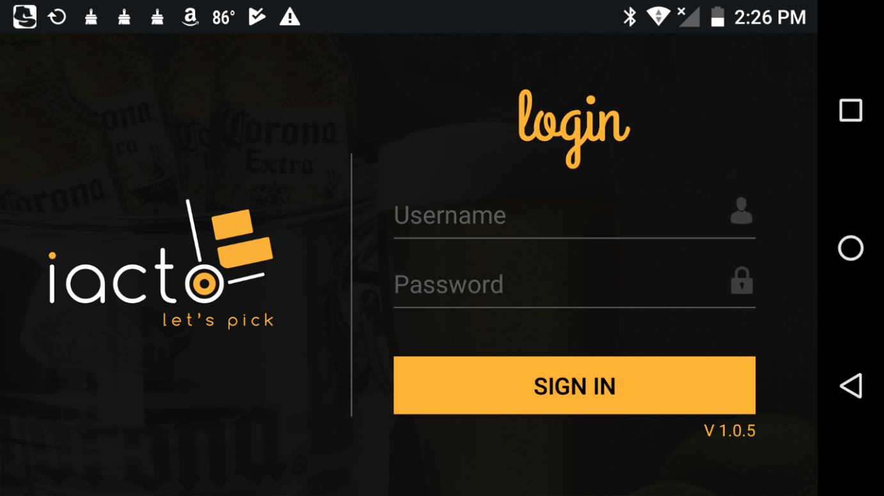

Figure: Login Screen

If username or password does not match, then an error message, ‘Invalid username or Password’ will be displayed.

### Profile Screen

On the ‘Profile’ screen, the picker can view his/her profile. The picker can also set new profile picture.

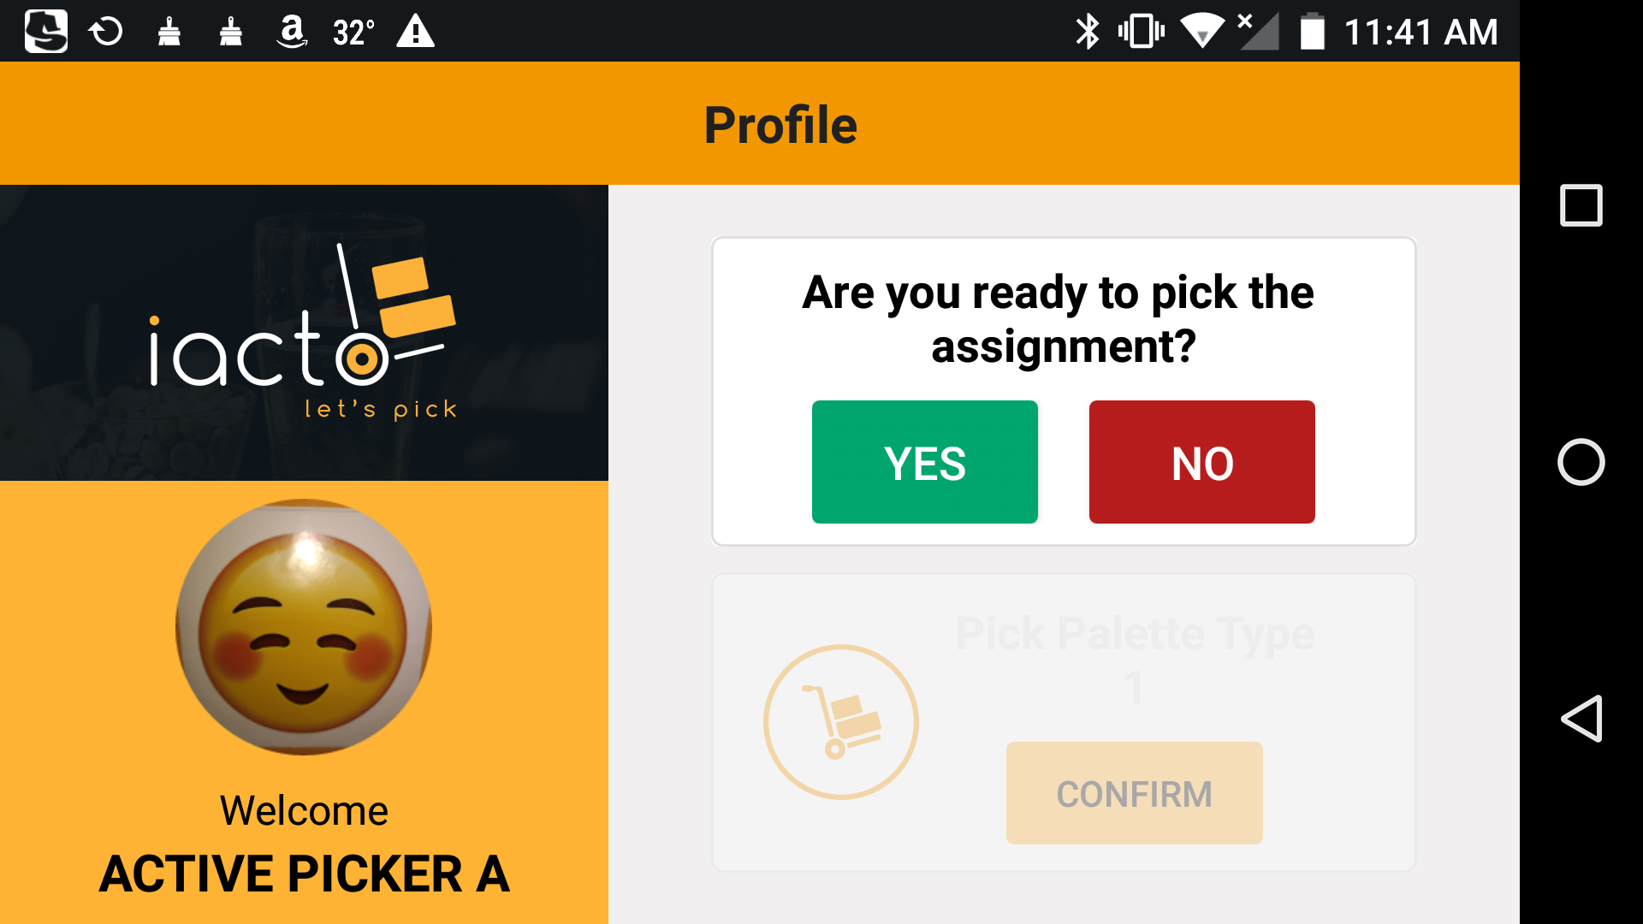

Figure: Profile Screen

If the picker is ready to pick an assignment, he/she has to tap the ‘YES’ button. The picker would then be able to view the allocated pallet type with a ‘Confirm’ option. If there is no assignment available, a popup message displaying the same will be displayed.

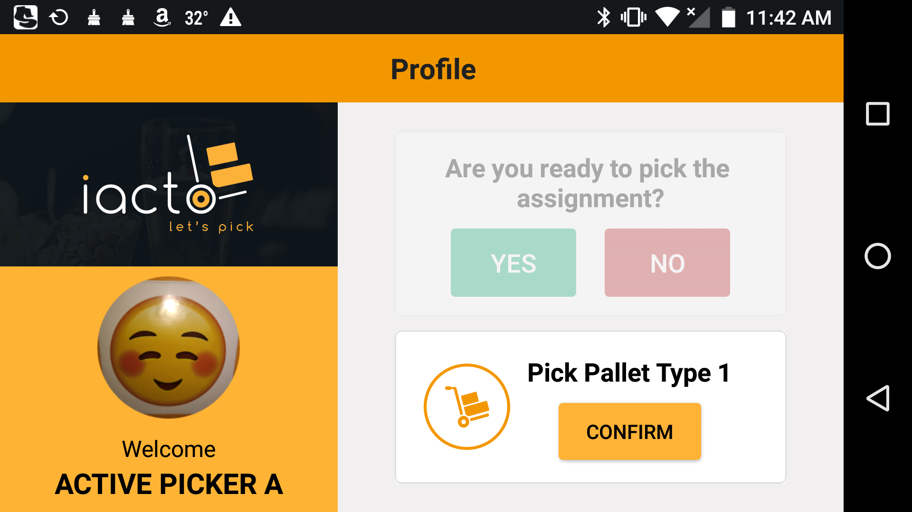

Figure: Profile Confirm Screen

If the picker taps on the ‘CONFIRM’ button, the page will be redirected to ‘Product Scanning’ page.

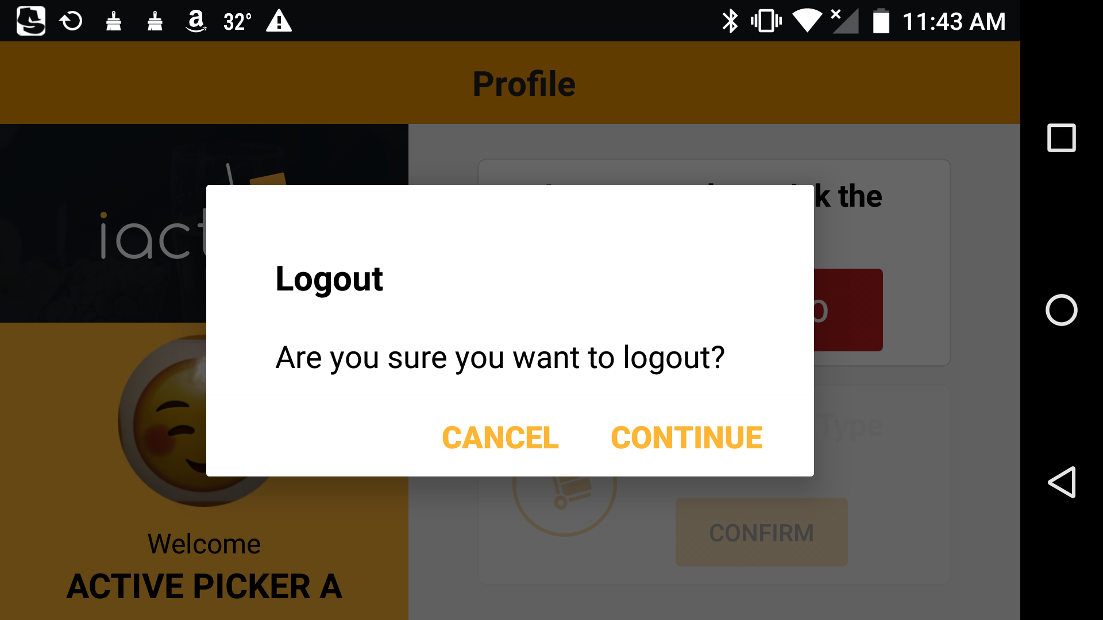

Figure: Profile logout Screen

If the picker taps on the ‘NO’ button, a popup message will be displayed with log-out option. By tapping on the ‘CONTINUE’ button, the picker can log out of the application.

### Product Scanning

On the ‘Product Scanning’ page, pickers can view the location, quantity of the product that needs to be picked, the name of the product with image, and a ‘skip’ option. In order to scan the product, the picker uses a finger scanner connected to the device via Bluetooth.

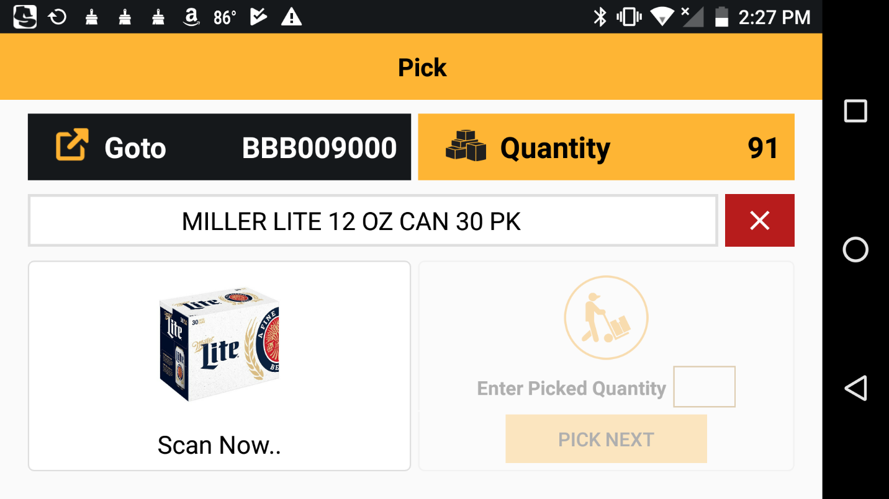

Figure: Product Scanning Screen 1.1

Once the product barcode is scanned and it matches the assigned barcode, the ‘Scan Now’ changes to ‘Scanned’, and the product pick option (‘Pick Next’) will be active. In the product pick option, the picker can enter the picked quantity and confirm the same by tapping ‘Pick Next’ button.

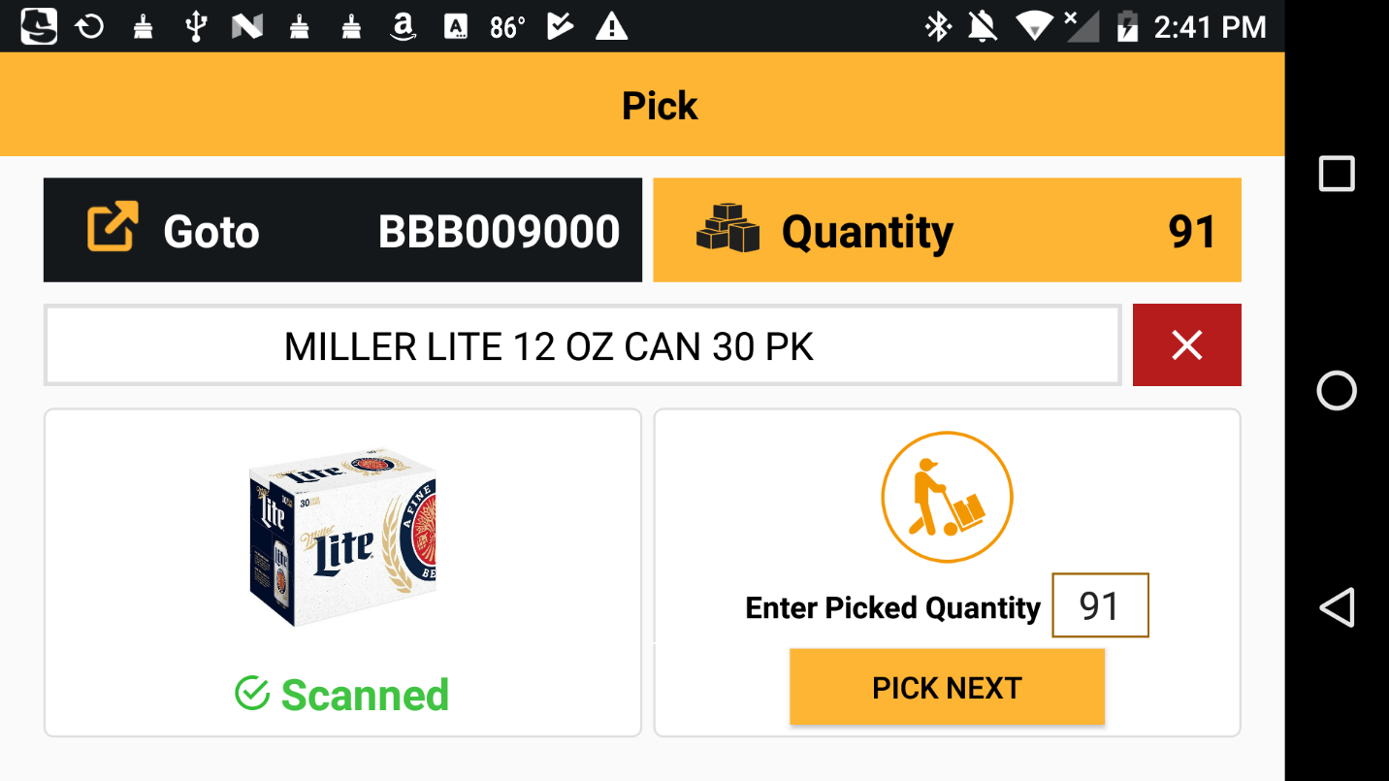

Figure: Product Scanning Screen 1.2

If the entered ‘picked quantity’ does not match the assigned quantity, a ‘mismatch’ popup message will be displayed.

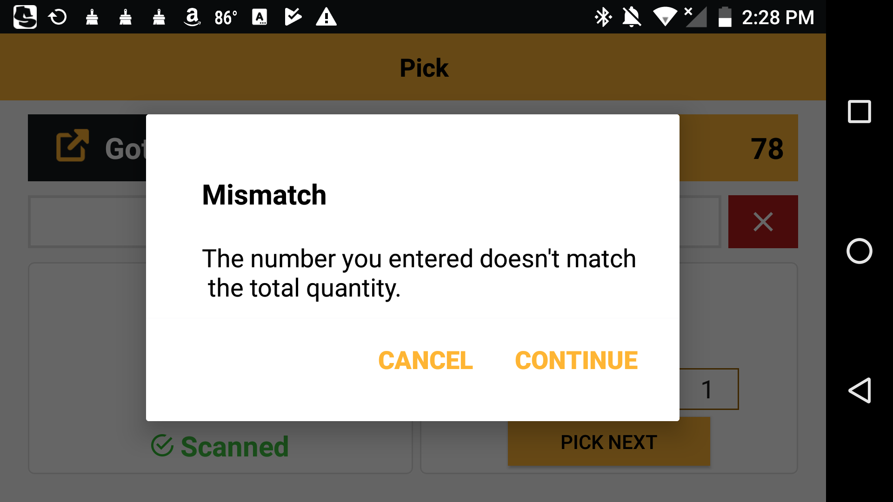

Figure: Product Scanning Screen 1.3

By tapping the ‘CONTINUE’ button in the mismatch popup message, a new page is displayed where the total number of cartons picked is to be entered. Then the user needs to tap the ‘NEXT’ button.

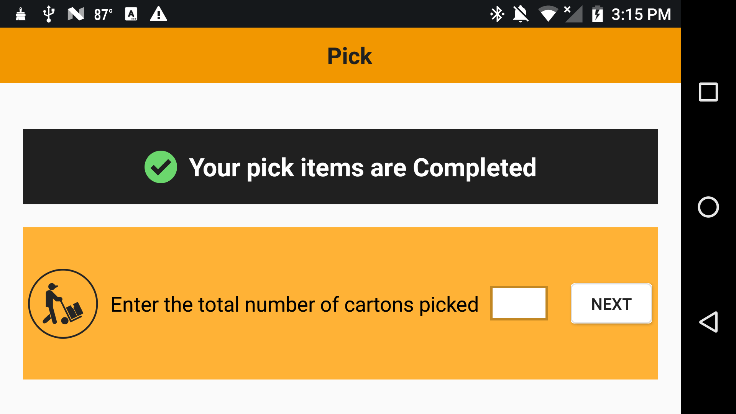

Figure: Product Scanning Screen 1.4

If the entered quantity matches the picked quantity, a popup message stating ‘Your assignment is COMPLETED’ is displayed. In addition, this popup window also provides an option to print packing sticker.

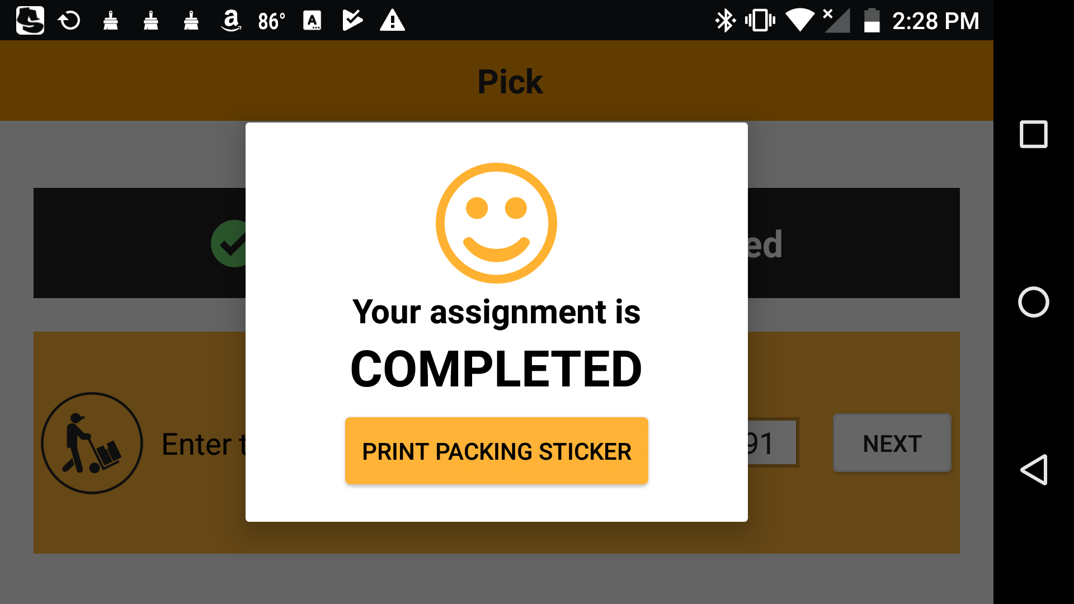

Figure: Product Scanning Screen 1.5

Once the assignment is completed, the user will be redirected to the ‘Profile’ page.

If the entered quantity does not match the picked quantity, a mismatch popup message will be displayed. In addition, this popup window also provides an option to retype the quantity.

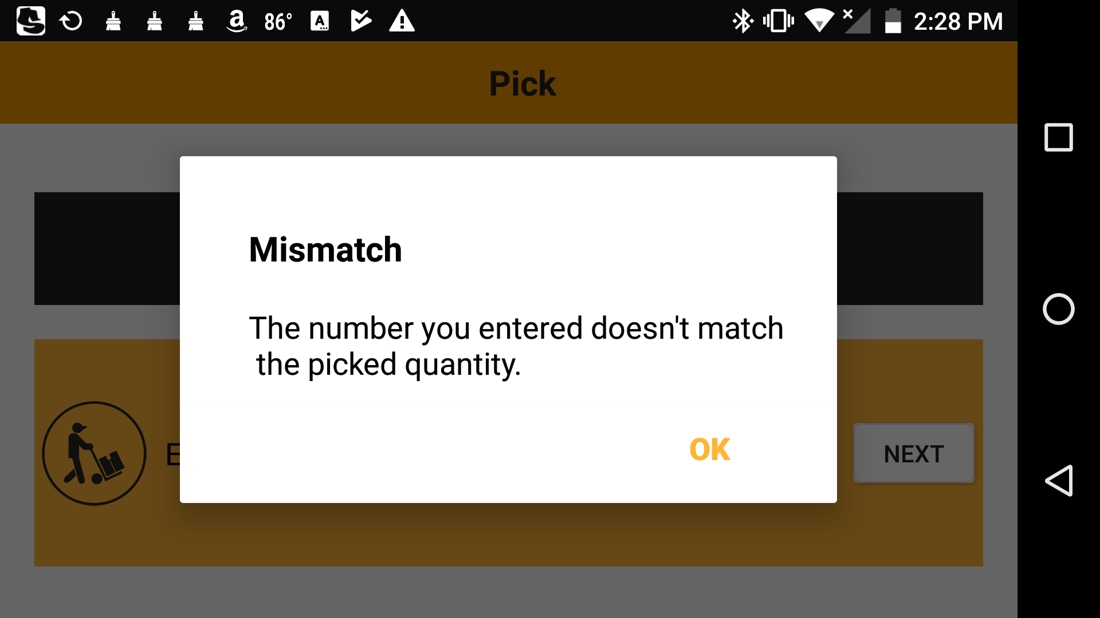

Figure: Product Scanning Screen 1.6

If the picker did not pick the assigned quantity completely and entered the respective picked quantity, then the entered quantity would be a mismatch with the ordered quantity. A mismatch popup message will then be displayed. In addition, this popup window also provides an option to contact the Floor Manager. (This section seems confusing… please rephrase)

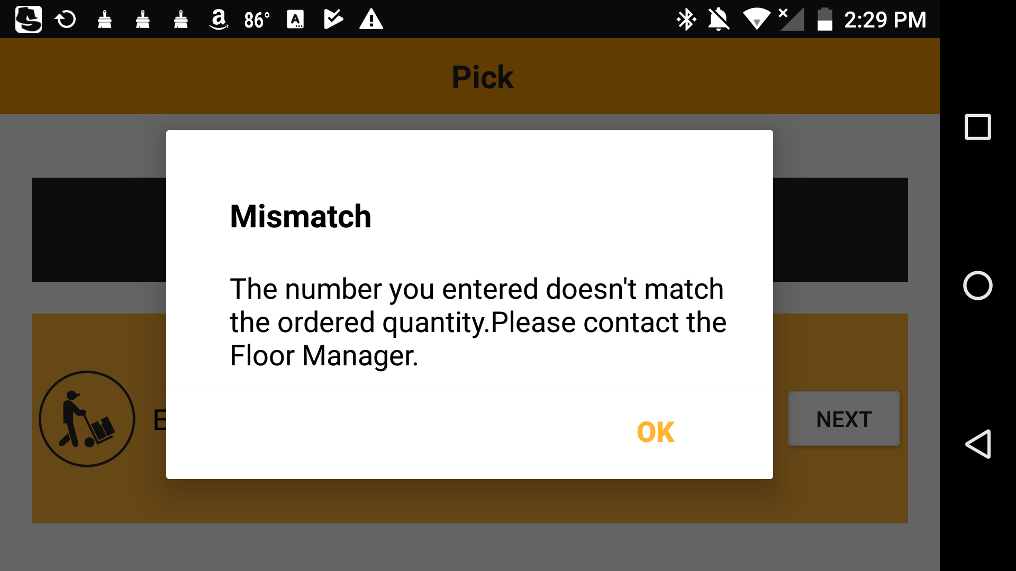

Figure: Product Scanning Screen 1.7

On tapping the ‘OK’ button, the Floor Manager Confirmation popup window will be displayed. Picker can continue this assignment with the help of the Floor Manager. Floor manager should provide login credentials and continue the assignment by touching ‘CONTINUE’ button.

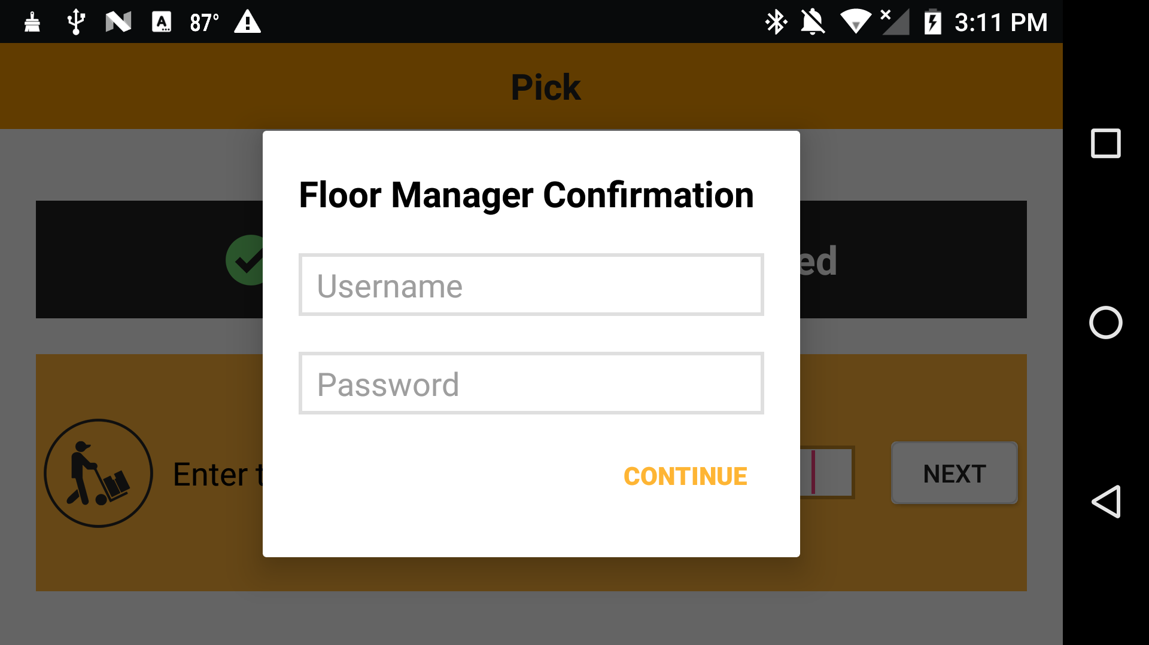

Figure: Product Scanning Screen 1.8

Finally, if the entered Floor Manager login credentials are valid, a popup message stating that ‘Your assignment is COMPLETED’ will be displayed, and an option to print packing sticker is provided.



Figure: Product Scanning Screen 1.9

(Is there confirmation for printing? Print errors)

# Troubleshoot

|  |  |  |
| --- | --- | --- |
| Problem | Cause | Solution |
| User unable to login to mobile application. | The user name or password is invalid. | * Enter valid user credentials for login. * If the user forgot the login credentials, Contact Floor Manager. |
| User unable to login to application without membership. | Contact Floor Manager |
| User can’t view their own updated profile picture in mobile app. | Mobile devices cookies and cache related issue. | Clear all cookies and cache from the device. |
| Mobile app displays ‘No network available’ pop-up message. | The internet connectivity of the device is not turned ON. | Turn ON the device internet connectivity. |
| The device is not in the network’s service area. | * Check with your service provider whether network is available in the service area. * If network is available, contact Floor Manager. * If network is not available, the mobile may be used in the networking area. |
| Poor signal | Contact Floor Manager |
| Unable to scan product barcode using mobile app. | The Bluetooth connectivity of the mobile device is not turned ON. | Turn ON the mobile device Bluetooth connectivity. |
| The Bluetooth scanner is not turned ON. | Turn ON the Bluetooth scanner. |
| The Bluetooth scanner is not paired with mobile device. | Pair the Bluetooth scanner device with mobile device.  (Refer to the User manual of the Bluetooth device) |
| The Bluetooth scanner is not in the Bluetooth network’s service area. | * Check whether the Bluetooth device is in the mobile Bluetooth transmitting range. * If the Bluetooth device is in the mobile Bluetooth transmitting range, contact Floor Manager. * If the Bluetooth device is not in the mobile Bluetooth transmitting range, the device may be used in the transmitting range. |
| Print does not work. | The printer is not turned ON. | Turn ON the printer device. |
| The printer is not securely connected with computer with internet or wireless network.  (Is the print service working?) | * Check whether the printer is connected to computer or wireless network properly. * If not, the printer may be connected properly. |
| Floor Manager unable to login to web application. | The user name or password is invalid.: | * Enter valid user credentials for login. * If the Floor Manager forgot the login credentials, Contact Admin. |
| User unable to login to application without membership. | Contact Admin |

**\*\*\*\*\*\*\*\*\*\*\*\*\*\*\*\*\*\*\*\*\*\*\*\***